Aim: To study Preprocessing of text (Tokenization, Filtration, Script Validation, Stop Word Removal, Stemming)
IDE: Google Collab

Theory:
To preprocess your text simply means to bring your text into a form that is predictable and analyzable for your task. A task here is a combination of approach and domain. Machine Learning needs data in a numeric form. We basically used encoding techniques (Bag Of Words, Bi-gram, n-gram, TF-IDF, Word2Vec) to encode text into a numeric vector. But before encoding, we first need to clean the text data, and the process to prepare (or clean) text data before encoding is called text preprocessing. This is the very first step to solving the NLP problems.

Tokenization:
Tokenization is about splitting strings of text into smaller pieces, or "tokens". Paragraphs can be tokenized into sentences, and sentences can be tokenized into words.

Filtration:
Similarly, if we are doing simple word counts or trying to visualize our text with a word cloud, stopwords are some of the most frequently occurring words, but don't really tell us anything. We're often better off tossing the stopwords out of the text. By checking the Filter Stopwords option in the Text Pre-processing tool, you can automatically filter these words out.

Stemming:
Stemming is the process of reducing inflection in words (e.g., troubled, troubles) to their root form (e.g., trouble). The "root" in this case may not be a real root word, but just a canonical form of the original word.
Stemming uses a crude heuristic process that chops off the ends of words in the hope of
Actually, converting them to trouble instead of trouble because the ends were just chopped off (ughh, how crude!). There are different algorithms for stemming. The most common algorithm, which is also known to be empirically effective for English, is Porter's Algorithm. Here is an example of stemming in action with Porter Stemmer:

original word stemmed words
0 connect connect
'I connected connect
- connection connect
- connections connect
- connects connect

Stopword Removal
Stop words are a set of commonly used words in a language. Examples of stop words in English are "a", ‘‘the", "is", "are", etc. The intuition behind using stop words is that, by removing low-information words from text, we can focus on the important words instead.
For example, in the context of a search system, if your search query is 'what is text preprocessing?", you want the search system to focus on surfacing documents that talk about text preprocessing over documents that talk about what is. This can be done by preventing all words from your stop word list from being analyzed. Stop words are commonly applied in search systems, text classification applications, topic modeling, topic extraction, and others. Stop word removal, while effective in search and topic extraction systems, is non-critical in classification systems. However, it does help reduce the number of features in consideration, which helps keep your models decently sized

Program (Code):
To be attached to
- Tokenization
- Filtration
- StopWords Removal
- PoS Tagging
- Noun Phrase Chunking
- Dependency Parsing
text="""Nishith Kotak is teaching NLP programming in the
class of Semester 6 for the subject AI to
BTech ICT students in MA112, Marwadi University,
Rajkot, India"""
type(text)
text[5]
#NLP: SPACY, NLTK, Gensim
import spacy
#load the language model
nlp=spacy.load('en_core_web_sm')
doc=nlp(text)
#Named Entity Recognition: NER
for token in doc.ents:
print(token.text, token.label_)
#POS Tags: Part of Speech tagging
text="Let's google it"
doc=nlp(text)
for token in doc:
print(token.text,"-->",token.pos_)
#Stemming vs lemmatization
text="""I studied AI subject and
then meeting Mr. Sachin in a meeting"""
doc=nlp(text)
doc
#stemming
import nltk
from nltk.stem.porter import *
p_stem=PorterStemmer()
for word in text.split():
print(word,"-->",p_stem.stem(word))
#lemmatization
for token in nlp(text):
print(token.text,"-> ",token.pos_,
"->",token.lemma_)

Results:

NER

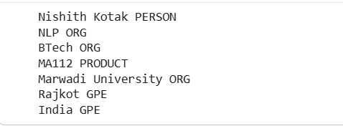

POS

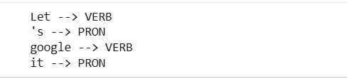

Stemming

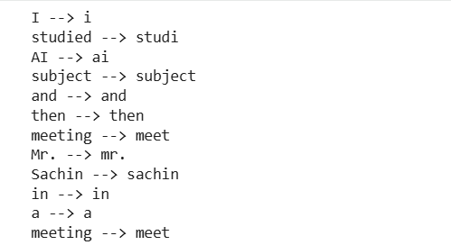

Lemmatization

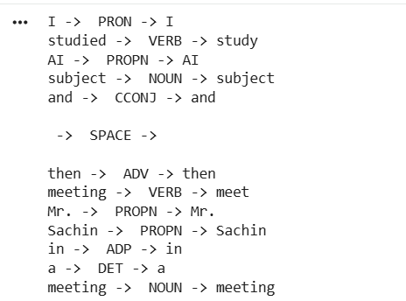

Observation:

Post Lab Exercise:
- Take your own document of 10 sentences and perform the same tasks. Attach code and screenshot of your output.
Code:
text = """To preprocess your text simply means to bring your text into a form that is predictable and analyzable for your task.
A task here is a combination of approach and domain. Machine Learning needs data in a numeric form. We basically used encoding techniques to encode text into a numeric vector.
But before encoding, we first need to clean the text data, and the process to prepare (or clean) text data before encoding is called text preprocessing.
This is the very first step to solving the NLP problems."""
import spacy
#load the language model
nlp = spacy.load('en_core_web_sm') #english, core, web, small version
doc = nlp(text)
#Named Entity Recognition(NER)
for token in doc.ents:
print(token.text, token.label_)
# POS Tags: Part of speech tagging
for token in doc:
print(token.text, "-->", token.pos_)
#Stemming
import nltk
from nltk.stem.porter import *
p_stem=PorterStemmer()
for word in text.split():
print(word,"-->",p_stem.stem(word))

#Lemmatization
for token in nlp(text):
print(token.text,"-> ",token.pos_,
"->",token.lemma_)
Output:
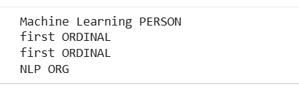
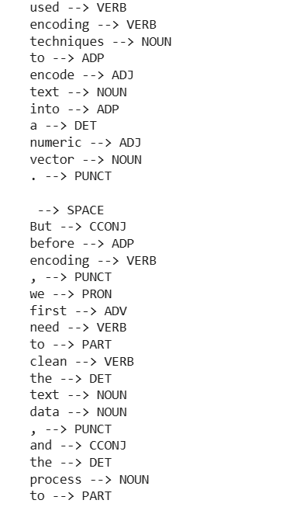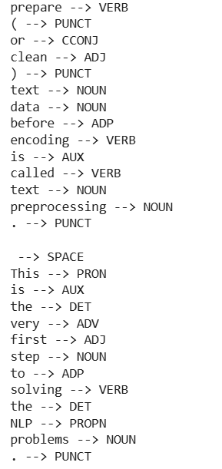
Stemming
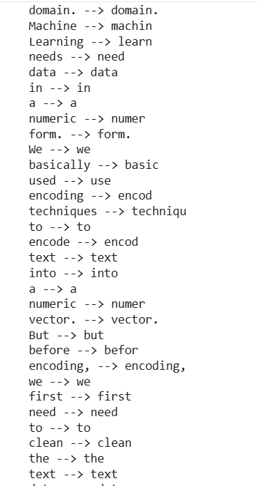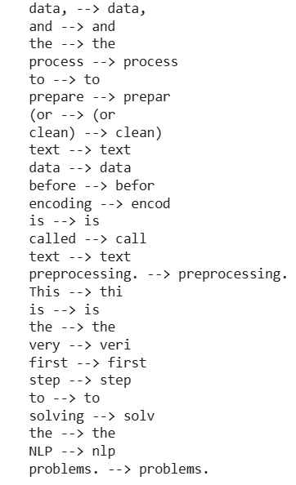
Lemmatization
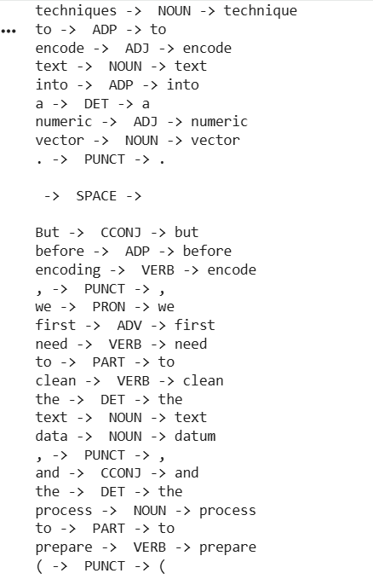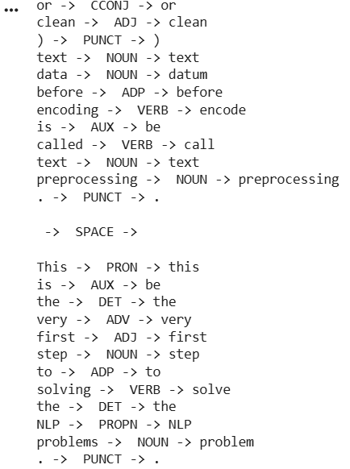
- Write your observation on stemming and lemmatization you obtained for the sentences.
As expected, lemmatization returned the more accurate words, while stemming returned less accurate words, even though it was faster than lemmatization.
Stemming just strips the prefixes or suffixes of the words to produce a root form. Lemmatization uses linguistic rules to return a valid base word.

